**More Sql Exercises: AdventureWorks db**

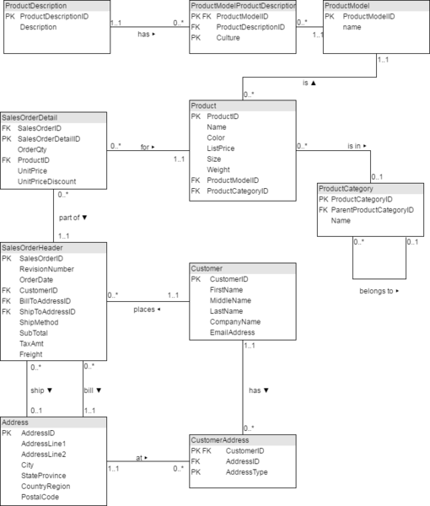

1. **Show the first name and the email address of customer with CompanyName 'Bike World'**

select FirstName, EmailAddress

FROM customer

WHERE CompanyName = "Bike World"

1. **Show the CompanyName for all customers with an address in City 'Dallas'.**

select CompanyName

FROM customer

INNER JOIN customeraddress

ON customer.CustomerID = customeraddress.CustomerID

INNER JOIN address

ON customeraddress.AddressID = address.AddressID

WHERE City = "Dallas"

1. **How many items with ListPrice more than $1000 have been sold?**

select COUNT(ListPrice)

FROM product

WHERE ListPrice > 1000

1. **Give the CompanyName of those customers with orders over $100000. Include the subtotal plus tax plus freight.**

select CompanyName

FROM customer

INNER JOIN salesorderheader

ON customer.customerID = salesorderheader.CustomerID

WHERE TotalDue > 100000

1. **Find the number of left racing socks ('Racing Socks, L') ordered by CompanyName 'Riding Cycles'**

select COUNT(Name)

FROM product

INNER JOIN salesorderdetail

ON product.productID = salesorderdetail.productID

INNER JOIN salesorderheader

ON salesorderdetail.SalesOrderID= salesorderheader.SalesOrderID

INNER JOIN customer

ON salesorderheader.CustomerID = customer.CustomerID

WHERE product.Name = 'Racing Socks, L' AND CompanyName = 'Riding Cycles'

1. **A "Single Item Order" is a customer order where only one item is ordered. Show the SalesOrderID and the UnitPrice for every Single Item Order.**

select SalesOrderID, UnitPrice

FROM salesorderdetail

WHERE OrderQty = 1

1. **Where did the racing socks go? List the product name and the CompanyName for all Customers who ordered ProductModel 'Racing Socks'.**

select CompanyName, product.Name

FROM product

INNER JOIN salesorderdetail

ON product.productID = salesorderdetail.productID

INNER JOIN salesorderheader

ON salesorderdetail.SalesOrderID= salesorderheader.SalesOrderID

INNER JOIN customer

ON salesorderheader.CustomerID = customer.CustomerID

WHERE product.Name LIKE '%Racing Socks%'

1. **Show the product description for culture 'fr' for product with ProductID 736.**

select description

FROM productdescription

INNER JOIN productmodelproductdescription

ON productdescription.ProductDescriptionID = productmodelproductdescription.ProductDescriptionID

INNER JOIN product

ON product.ProductModelID = productmodelproductdescription.ProductModelID

WHERE Culture = 'fr' AND product.ProductID = 736

1. **Use the SubTotal value in SaleOrderHeader to list orders from the largest to the smallest. For each order show the CompanyName and the SubTotal and the total weight of the order.**

select CompanyName, SubTotal, weight, OrderQty, weight*OrderQty AS 'Total Weight'

FROM customer

INNER JOIN salesorderheader

ON customer.CustomerID= salesorderheader.CustomerID

INNER JOIN salesorderdetail

ON salesorderheader.SalesOrderID= salesorderdetail.SalesOrderID

INNER JOIN product

ON product.ProductID = salesorderdetail.ProductID

ORDER BY SubTotal DESC

1. **How many products in ProductCategory 'Cranksets' have been sold to an address in 'London'?**

select SUM(orderQty)

FROM salesorderdetail

JOIN salesorderheader

ON salesorderheader.SalesOrderID= salesorderdetail.SalesOrderID

JOIN customer

ON customer.CustomerID = salesorderheader.CustomerID

JOIN customeraddress

ON customer.CustomerID = customeraddress.CustomerID

JOIN address

ON customeraddress.AddressID = address.AddressID

JOIN product

ON product.ProductID = salesorderdetail.ProductID

JOIN productcategory

ON productcategory.ProductCategoryID = product.ProductCategoryID

WHERE productcategory.Name = 'Cranksets' AND City = 'London'

1. **For every customer with a 'Main Office' in Dallas show AddressLine1 of the 'Main Office' and AddressLine1 of the 'Shipping' address - if there is no shipping address leave it blank. Use one row per customer.**

select DISTINCT CompanyName, BillToAddressID, ShipToAddressID, AddressLine1

FROM salesorderdetail

JOIN salesorderheader

ON salesorderheader.SalesOrderID= salesorderdetail.SalesOrderID

JOIN customer

ON customer.CustomerID = salesorderheader.CustomerID

JOIN customeraddress

ON customer.CustomerID = customeraddress.CustomerID

JOIN address

ON customeraddress.AddressID = address.AddressID

JOIN product

ON product.ProductID = salesorderdetail.ProductID

JOIN productcategory

ON productcategory.ProductCategoryID = product.ProductCategoryID

1. **For each order show the SalesOrderID and SubTotal calculated three ways:   
   A) From the SalesOrderHeader**

select salesorderheader.SalesOrderID, SubTotal

FROM salesorderdetail

JOIN salesorderheader

ON salesorderheader.SalesOrderID= salesorderdetail.SalesOrderID **B) Sum of OrderQty*UnitPrice**

select salesorderdetail.SalesOrderID, SubTotal, SUM(OrderQty*UnitPrice)

FROM salesorderdetail

JOIN salesorderheader

ON salesorderheader.SalesOrderID= salesorderdetail.SalesOrderID

GROUP BY salesorderdetail.SalesOrderID **C) Sum of OrderQty*ListPrice**

select salesorderdetail.SalesOrderID, SubTotal, SUM(OrderQty*ListPrice)

FROM salesorderdetail

JOIN salesorderheader

ON salesorderheader.SalesOrderID= salesorderdetail.SalesOrderID

INNER JOIN product

ON product.productID = salesorderdetail.productID

GROUP BY salesorderdetail.SalesOrderID

1. **Show the best selling item by value**

select OrderQty, UnitPrice, ListPrice

FROM salesorderdetail

JOIN salesorderheader

ON salesorderheader.SalesOrderID= salesorderdetail.SalesOrderID

INNER JOIN product

ON product.productID = salesorderdetail.productID

ORDER BY OrderQty DESC

1. **Show how many orders are in the following ranges (in $):**

RANGE Num Orders Total Value

0- 99

100- 999

1000-9999

10000-

1. Top of Form

select count(SubTotal) as "Num Orders", sum(SubTotal) as "Total Value"

FROM salesorderdetail

JOIN salesorderheader

ON salesorderheader.SalesOrderID= salesorderdetail.SalesOrderID

WHERE SubTotal <= 99

select count(SubTotal) as "Num Orders", sum(SubTotal) as "Total Value"

FROM salesorderdetail

JOIN salesorderheader

ON salesorderheader.SalesOrderID= salesorderdetail.SalesOrderID

WHERE SubTotal >= 100 AND SubTotal <= 999

select count(SubTotal) as "Num Orders", sum(SubTotal) as "Total Value"

FROM salesorderdetail

JOIN salesorderheader

ON salesorderheader.SalesOrderID= salesorderdetail.SalesOrderID

WHERE SubTotal >= 1000 AND SubTotal <= 9999

select count(SubTotal) as "Num Orders", sum(SubTotal) as "Total Value"

FROM salesorderdetail

JOIN salesorderheader

ON salesorderheader.SalesOrderID= salesorderdetail.SalesOrderID

WHERE SubTotal >= 10000

1. **Identify the three most important cities. Show the break down of top level product category against city.**

select City, productcategory.Name, sum(SubTotal) as "Total Value"

FROM salesorderdetail

JOIN salesorderheader

ON salesorderheader.SalesOrderID= salesorderdetail.SalesOrderID

JOIN customer

ON customer.CustomerID = salesorderheader.CustomerID

JOIN customeraddress

ON customer.CustomerID = customeraddress.CustomerID

JOIN address

ON customeraddress.AddressID = address.AddressID

JOIN product

ON product.ProductID = salesorderdetail.ProductID

JOIN productcategory

ON productcategory.ProductCategoryID = product.ProductCategoryID

group by city

order by "Total Value" DESC LIMIT 3

1. **List the SalesOrderNumber for the customer 'Good Toys' 'Bike World'**

select SalesOrderID, CompanyName

FROM salesorderheader

JOIN Customer

ON salesorderheader.CustomerID= customer.CustomerID

WHERE CompanyName = 'Good Toys' or CompanyName = 'Bike World'

1. **List the ProductName and the quantity of what was ordered by 'Futuristic Bikes'**

select product.Name, OrderQty

FROM salesorderdetail

JOIN salesorderheader

ON salesorderheader.SalesOrderID= salesorderdetail.SalesOrderID

JOIN product

ON salesorderdetail.ProductID = product.ProductID

JOIN Customer

ON salesorderheader.CustomerID= customer.CustomerID

WHERE CompanyName = 'Futuristic Bikes'

1. **Find the best customer in each region.**

select sum(subtotal) as 'Sale total', CompanyName, CountryRegion

FROM salesorderheader

JOIN Customer

ON salesorderheader.CustomerID= customer.CustomerID

JOIN salesorderdetail

ON salesorderheader.SalesOrderID= salesorderdetail.SalesOrderID

JOIN address

ON salesorderheader.ShipToAddressID = address.AddressID

group by CompanyName

order by 'Sale total' desc